**DAILY ONLINE ACTIVITIES SUMMARY**

|  |  |  |  |  |  |  |  |  |
| --- | --- | --- | --- | --- | --- | --- | --- | --- |
| **Date:** | **19/05/2020** | | | | | **Name:** | **V ANJANA PAI** | |
| **Sem & Sec** | **IV sem & B section** | | | | | **USN:** | **4AL18CS094** | |
| **Online Test Summary** | | | | | | | | |
| **Subject** | | **Design and Analysis of Algorithms** | | | | | | |
| **Max. Marks** | | **30** | | **Score** | | | **8** | |
| **Certification Course Summary** | | | | | | | | |
| **Course** | **Python for Machine Learning** | | | | | | | |
| **Certificate Provider** | | | **Greatlearning academy** | | **Duration** | | | **5.0 hours** |
| **Coding Challenges** | | | | | | | | |
| **Problem Statement:** A user will input two strings, and we find if one of the strings is a sub sequence of the other. Program prints “yes” if either the first string is a sub sequence of the second string or the second string is a sub sequence of the first string. Assume that, the length of the first string is smaller than or equal to the length of the second string. | | | | | | | | |
| **Status: Executed** | | | | | | | | |
| **Uploaded the report in Github** | | | | | **YES** | | | |
| **If yes Repository name** | | | | | **Lockdown- coding** | | | |
| **Uploaded the report in slack** | | | | | **YES** | | | |

Online Test Summary: 18CS42 test was scheduled from 9:15 am t0 9:55 am And I have received the test score. The portion for the IA was 1st module there were 30 questions and the time assigned was 40 minutes the questions were mcq type. There were 20 questions of 1 mark and 5 questions of 2 mark.

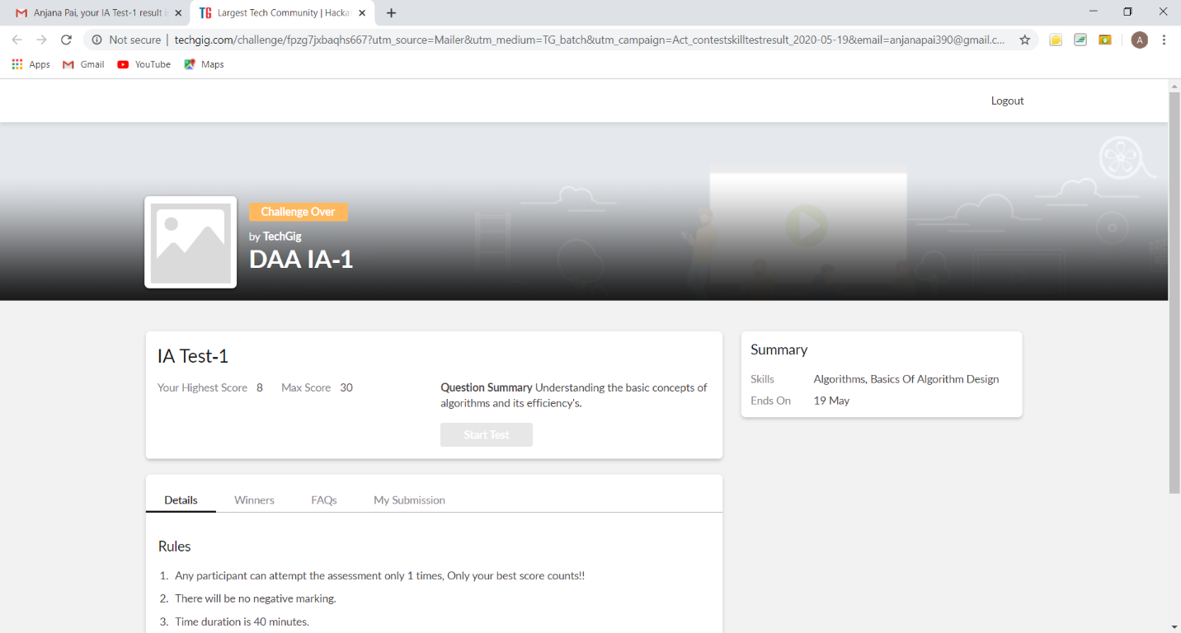

The above snap shot is the completion of the test and the marks allotted.

Online Certification Course Summary: Today I have continued with the course and learnt about Jupyter notebook shortcuts-2 where I have learnt about the jupyter notebooks, how to create a new note book and how to execute the code in the cell provided in the notebook and about some of the keyboard shortcuts which helps to execute the code and to achieve the output.

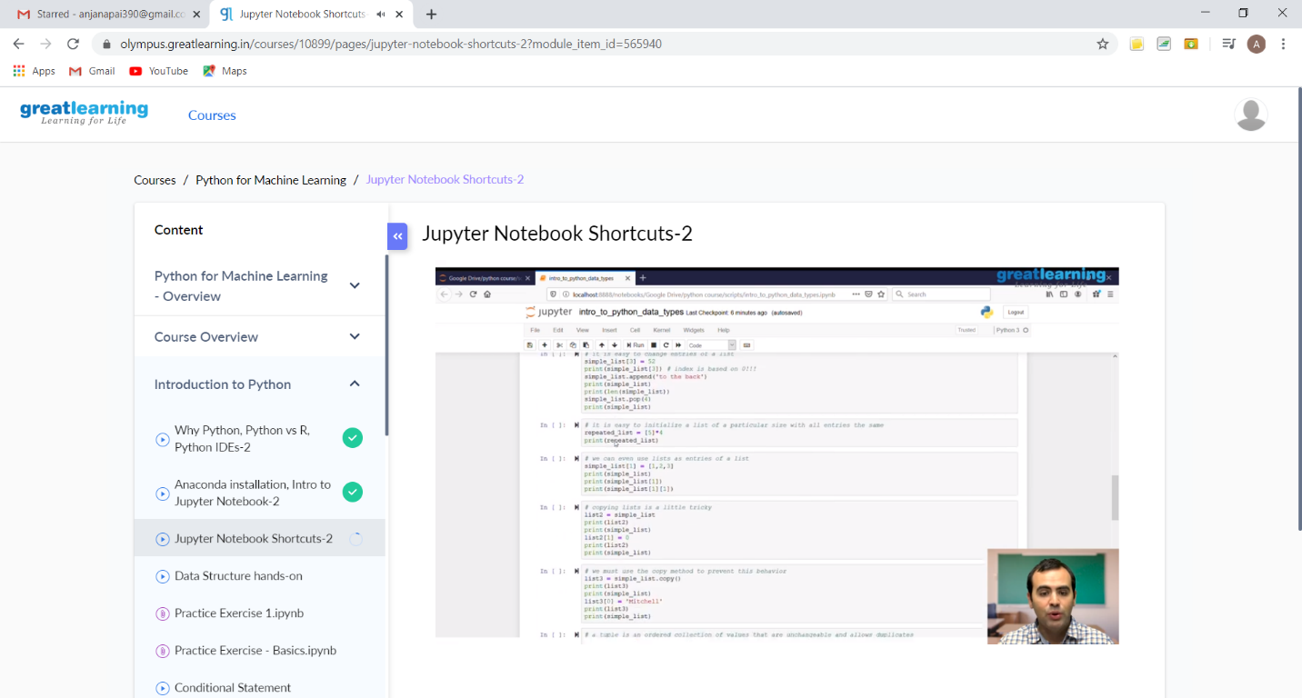

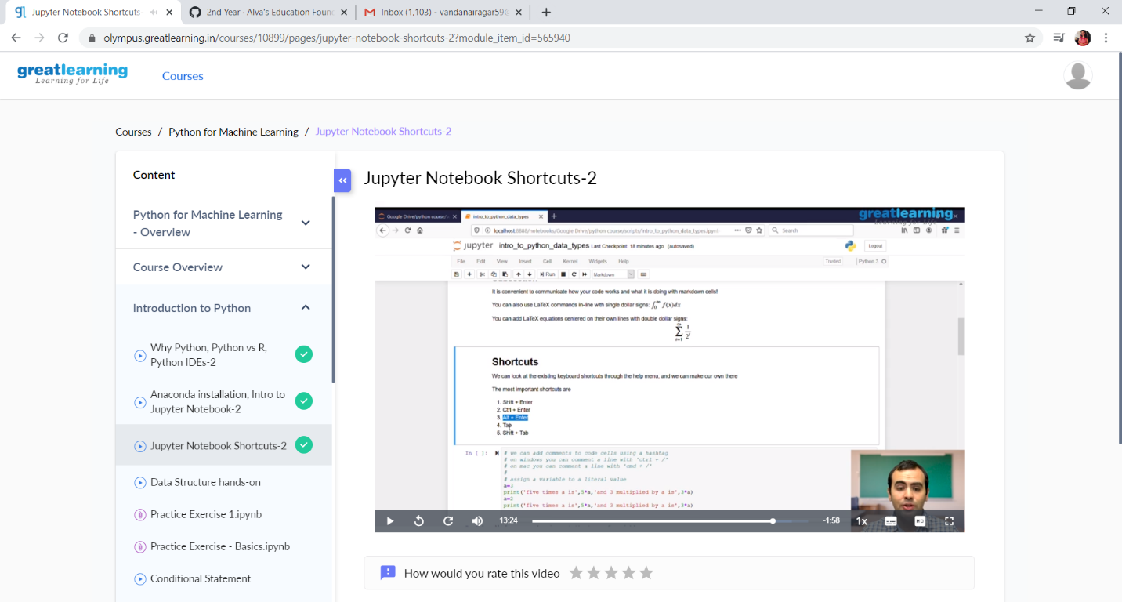

These are the snap shots of jupyter notebook and some of the shortcuts.

Online Coding Summary: **Online coding Summary: Today I had received one program from prof. Venkatesh CSE Dept. The program is mentioned above in the coding challenges(pg.01). I have also uploaded it to my GitHub repository.**

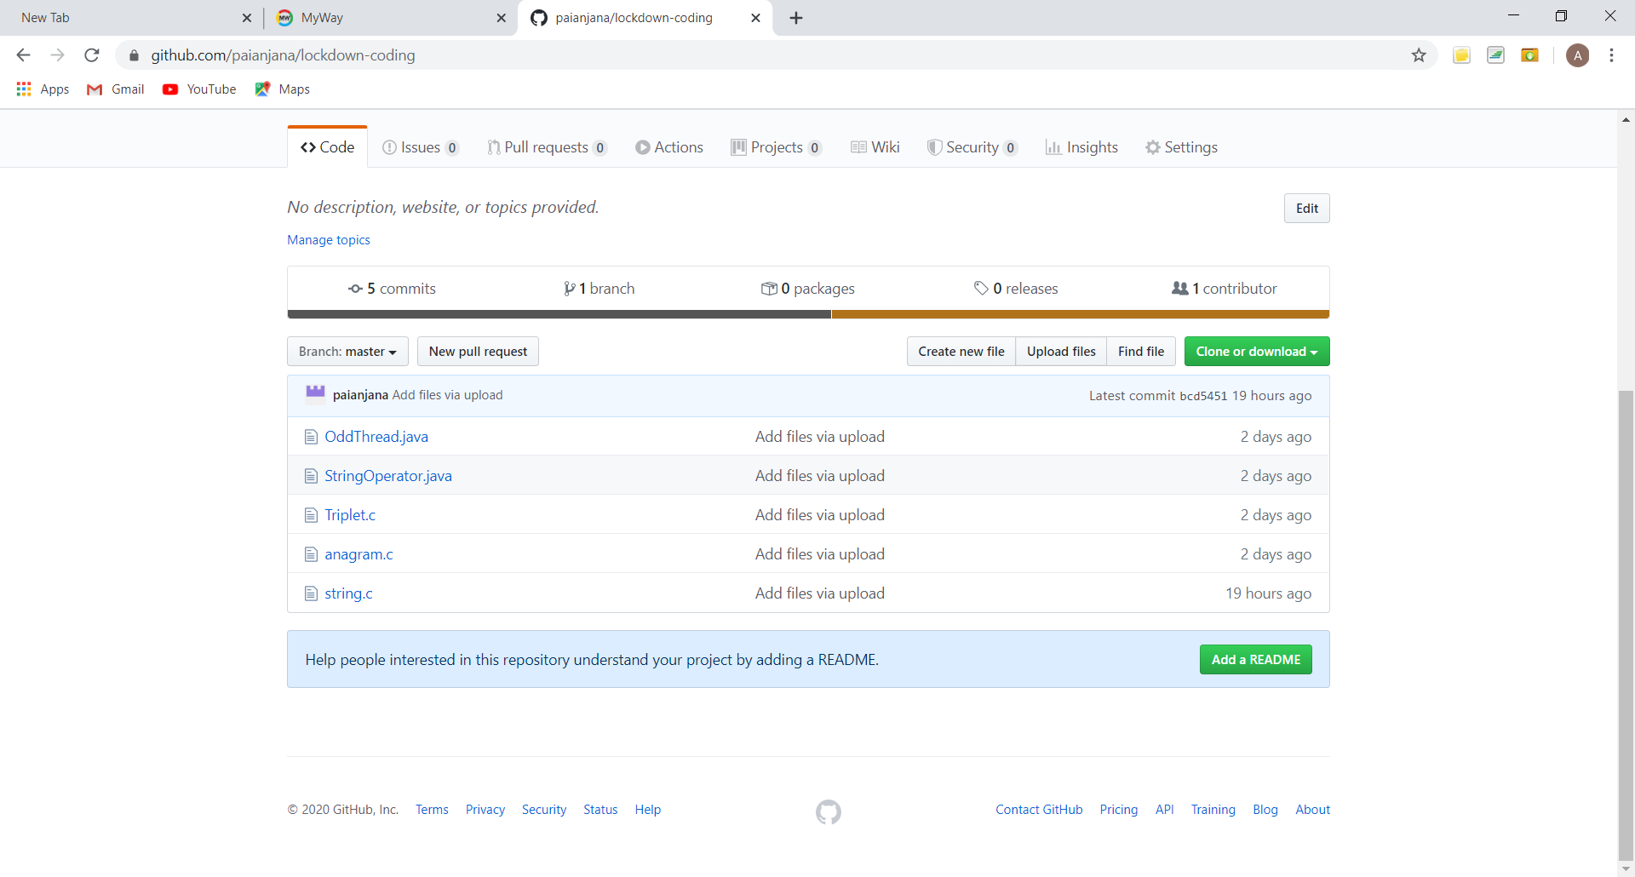

It is the snap shot of my repository where I have uploaded the code. File name is string.c